Customer Shopping Behavior Analysis
Project Overview
This initiative examines customer purchasing behavior by analyzing transactional data encompassing 3,900 transactions spread across multiple product categories. The objective is to extract meaningful insights regarding purchasing trends, distinct customer groups, item preferences, and subscription engagement to inform decision making strategies.
Dataset Summary
- Rows: 3,900
- Columns: 18
- Key Features:
  - Customer demographics (Age, Gender, Location, Subscription Status)
  - Purchase details (Item Purchased, Category, Purchase Amount, Season, Size, Color)
  - Shopping behavior (Discount Applied, Promo Code Used, Previous Purchases, Frequency of Purchases, Review Rating, Shipping Type)
- Missing Data: 37 values in Review Rating column
Exploratory Data Analysis using Python
The foundation involved data organization and refinement in Python:
- Data Loading: The dataset was brought into the environment utilizing pandas.
- Initial Exploration: Structural assessment was performed via df.info() and statistical summaries were generated using df.describe().
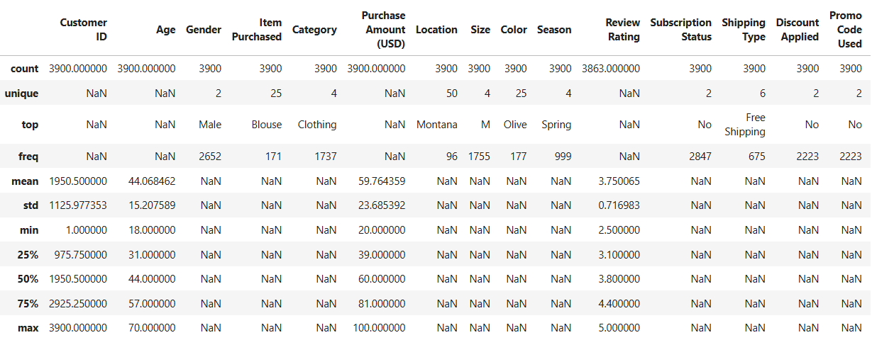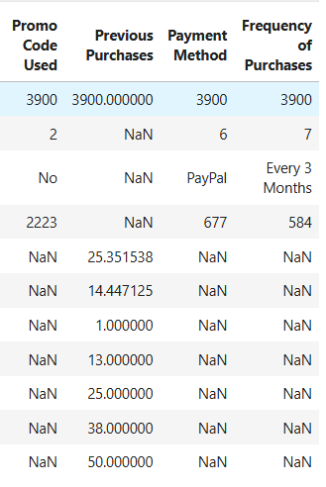
- Missing Data Handling: Null values were examined throughout the dataset with missing entries in the Review Rating column being filled using the median rating corresponding to each product category.
- Column Standardization: All column names were reformatted into snake case to enhance clarity and consistency in documentation.
- Feature Engineering:
  - An age_group column was constructed by segmenting customer ages into groups.
  - A purchase_frequency_days column was generated from transaction timing information.
- Data Consistency Check: An examination was conducted to determine whether discount_applied and promo_code_used contained overlapping information; promo_code_used was subsequently removed.
- Database Integration: The processed DataFrame was transferred from Python into a PostgreSQL database environment to enable SQL based examination.
Data Analysis using SQL (Business Transactions)
Systematic inquiries were executed in PostgreSQL to address key operational questions:
- Revenue by Gender - Examination of total revenue generation across male and female customer segments.
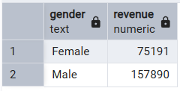
- High-Spending Discount Users - Identification of discount-using customers whose expenditure exceeded the average transaction value.
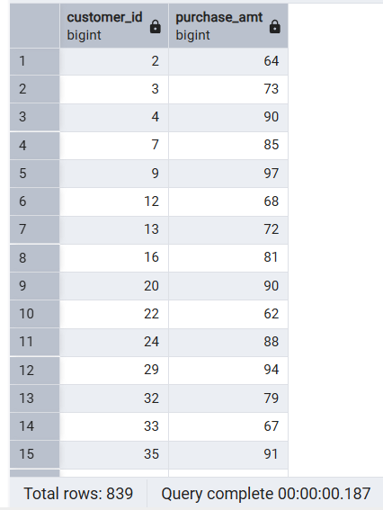
- Top 5 Products by Rating - Discovery of items with the most favorable average review scores.
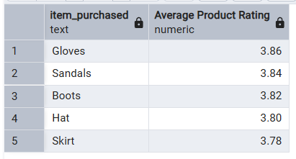
- Shipping Type Comparison - Assessment of average purchase values between Standard and Express delivery methods.
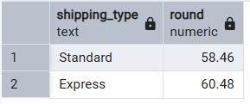
- Subscribers vs. Non-Subscribers - Analysis of average spending and aggregate revenue variation based on subscription enrollment.
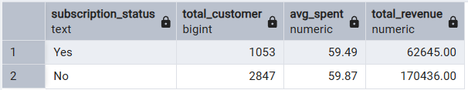
- Discount-Dependent Products - Detection of 5 items demonstrating the greatest reliance on discounted transactions.
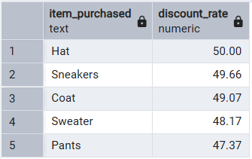
- Customer Segmentation - Categorization of customers into New, Returning, and Loyal classifications determined by purchase frequency.
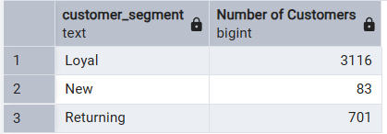
- Top 3 Products per Category - Compilation of best-performing items within each merchandise category.
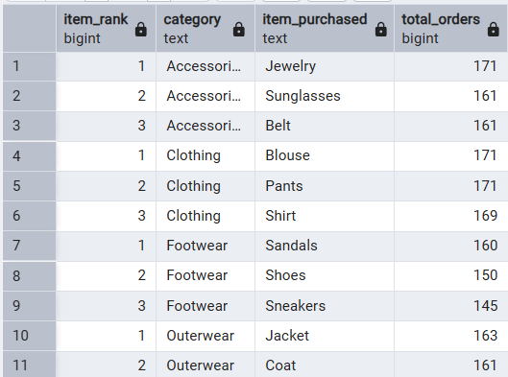
- Repeat Buyers & Subscriptions - Investigation of whether customers exceeding 5 purchases demonstrate higher subscription propensity.
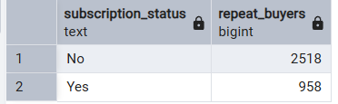
- Revenue by Age Group - Calculation of revenue contribution from each age segment.
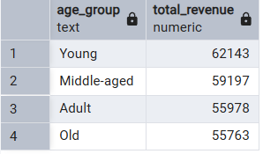
Dashboard in Power BI
An interactive visualization platform was constructed in Power BI to showcase the findings in graphical form.
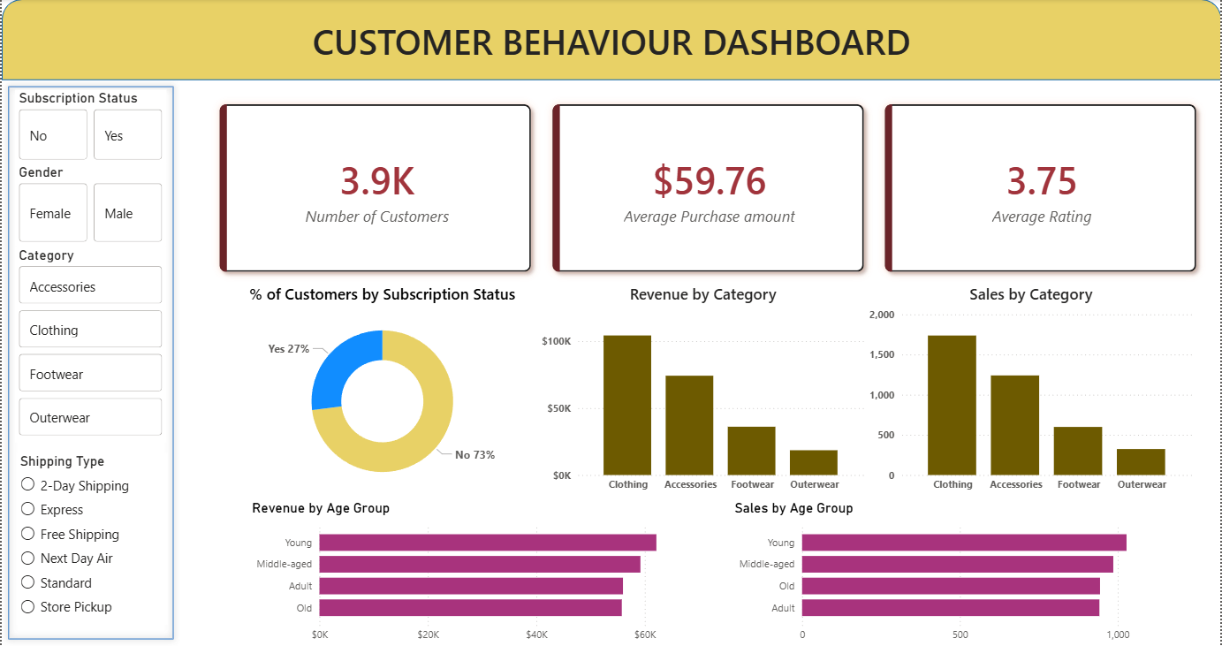
Business Recommendations
- Dynamic Shipping Thresholds: Leverage the higher spending behavior of "Express" users by introducing a free express shipping threshold slightly above the current average order value to encourage larger basket sizes.
- Seasonal Inventory Allocation: Utilize seasonal sales data to dynamically adjust stock levels for top-performing categories, reducing warehousing costs for off-peak merchandise.
- Volume-Based Discounting: Shift from generic markdowns to tiered offers (e.g., "Spend More, Save More") specifically targeting "High-Spending Discount Users" to protect margins while incentivizing bulk purchases.
- Demographic-Led Bundling: Create curated product bundles tailored to the specific preferences of the highest-revenue age groups identified in the demographic analysis.
- Targeted Subscription Conversion: Focus subscription marketing efforts strictly on the "Returning" customer segment (2-5 purchases), as this group demonstrates the highest probability of upgrading to a recurring revenue model.

